# Audio control

**Principle of passive buzzer:** The passive buzzer uses electromagnetic induction to drive the diaphragm to make sound when the electromagnet forms after the voice coil is connected to the alternating current to attract or repel the permanent magnet. It can only make sound when it is connected or disconnected. That is to say, you need to control the frequency of the high and low levels of output to produce sound, and control the frequency to produce different tones.

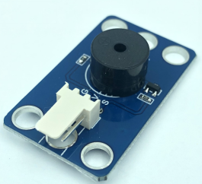

Course material

|  |
| --- |
|  |

## Install the audio control structure

|  |  |
| --- | --- |
| Remove the table lamp from the previous lesson, and the rest is as shown in the figure below.  拆完后 | |
| 音乐打击器_空白视图 6 | 音乐打击器_空白视图 6_1 |
| 音乐打击器_空白视图 6_2 | 音乐打击器_空白视图 6_3 |
| 音乐打击器_空白视图 6_4 | 音乐打击器_空白视图 6_5 |
| 音乐打击器_空白视图 6_6 | 音乐打击器_空白视图 6_7 |
| 音乐打击器_空白视图 6_8 | 音乐打击器_空白视图 6_9 |
| 音乐打击器_空白视图 6_10 |  |
|  | |

## Buzzer plays ringing tone

There is no program block to control the buzzer in the initial interface of SnailBlock. We need to load the passive buzzer plug-in.

The steps to add a plug-in are as follows:

1. Click the lower left corner to open the plug-in interface.

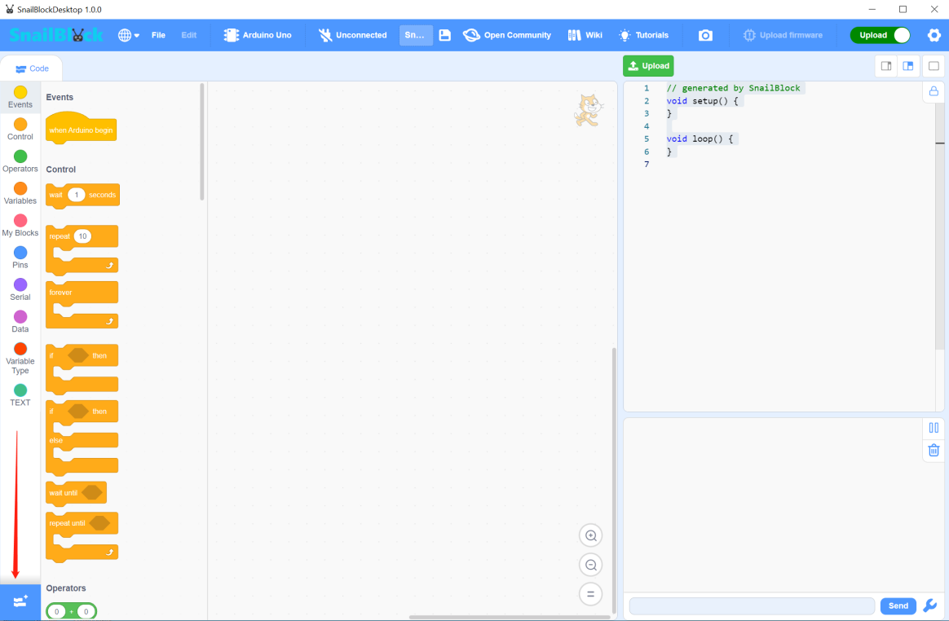

1. Find the passive buzzer and click it to display “Loaded”.

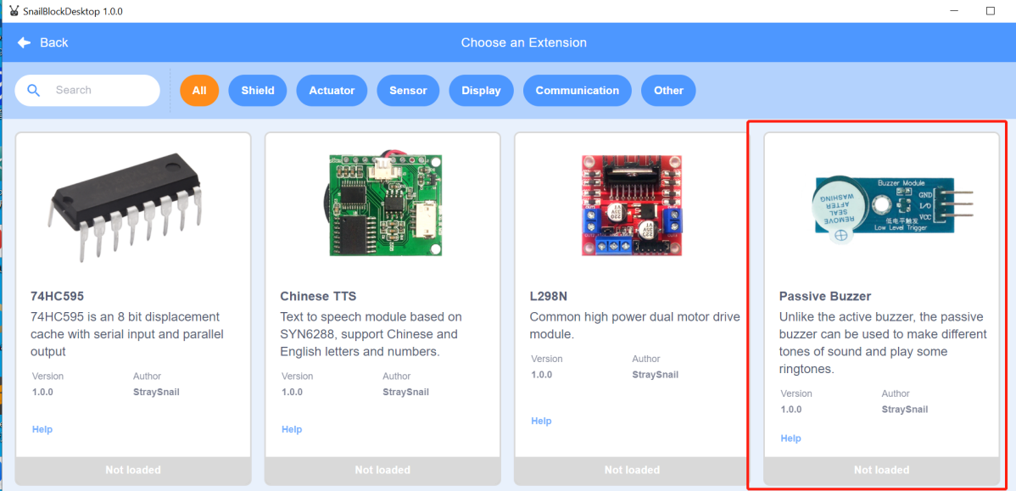

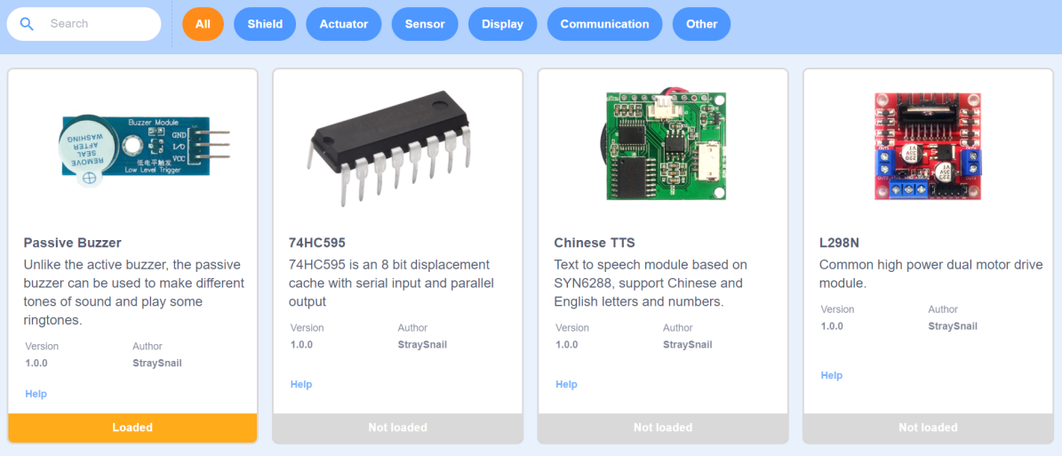

1. After loading successfully, click the top left corner to return to see the loaded buzzer program block.

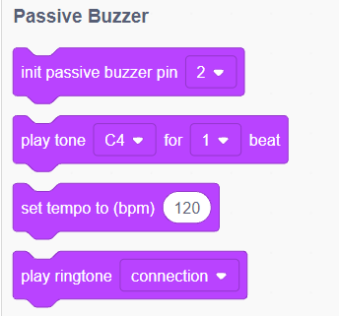

1. **Program block**

Initialize the passive buzzer pin which is connected to pin 3.

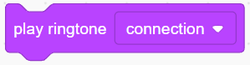Play ringtones. We have made many different ringtones. Just choose.

**（2）Example code**

|  |
| --- |
|  |

**（2）Experiment phenomenon**

The buzzer plays the song “Connect”.

**Tips: Play different ringtones.**

## Play basic tones

Use the play tone program block to control the buzzer to play do, re, mi, fa, so, la, si, do.

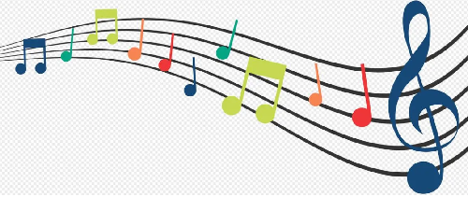

1. **Program block**

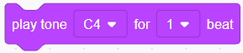It is used to control the buzzer to play the set tone and continuous beats.

**（2）Example code**

|  |
| --- |
|  |

**（3）Experiment phenomenon**

The buzzer plays “do, re, mi, fa, so, la, si, do”.

## A song

In the last lesson, we learned to add a buzzer plug-in, and use the buzzer plug-in to make the buzzer emit “do, re, mi, fa, so, la, si, do”. We can see that there are many tones to choose from the program block of playing tones.Songs are composed of different tones. Can we use these tones to write programs for playing songs?

Certainly, but before we write the program, we should learn to read the staff of the song. After all, we must understand the staff before we can write the song.

**（1）Staff**

Staff is the common music notation in the world today.

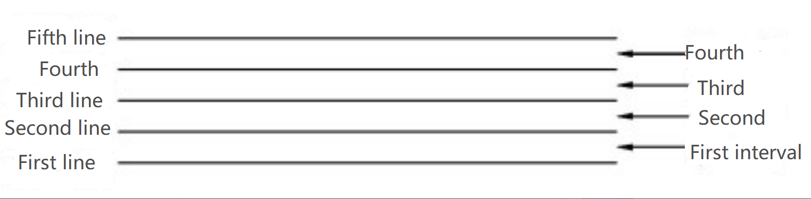

The staff is composed of five parallel horizontal lines and four parallel intervals, and their order is from bottom to top.

Lines:

From the bottom up, the first line, the second line, the third line, the fourth line, and the top one is the fifth line.

Spaces:

Because there are so many notes, the gap between the lines must not be wasted, which is called “space”. The spaces are also counted from bottom to top, just like the lines. The bottom one is the first space, and the top one is the fourth space.

Ledger line and extra space

If the line and space are not enough, you can add the line and space above or below the staff. The added line and space are respectively called the first line above, the first room above, the first line below, and the first room below. (As shown in Figure 2)

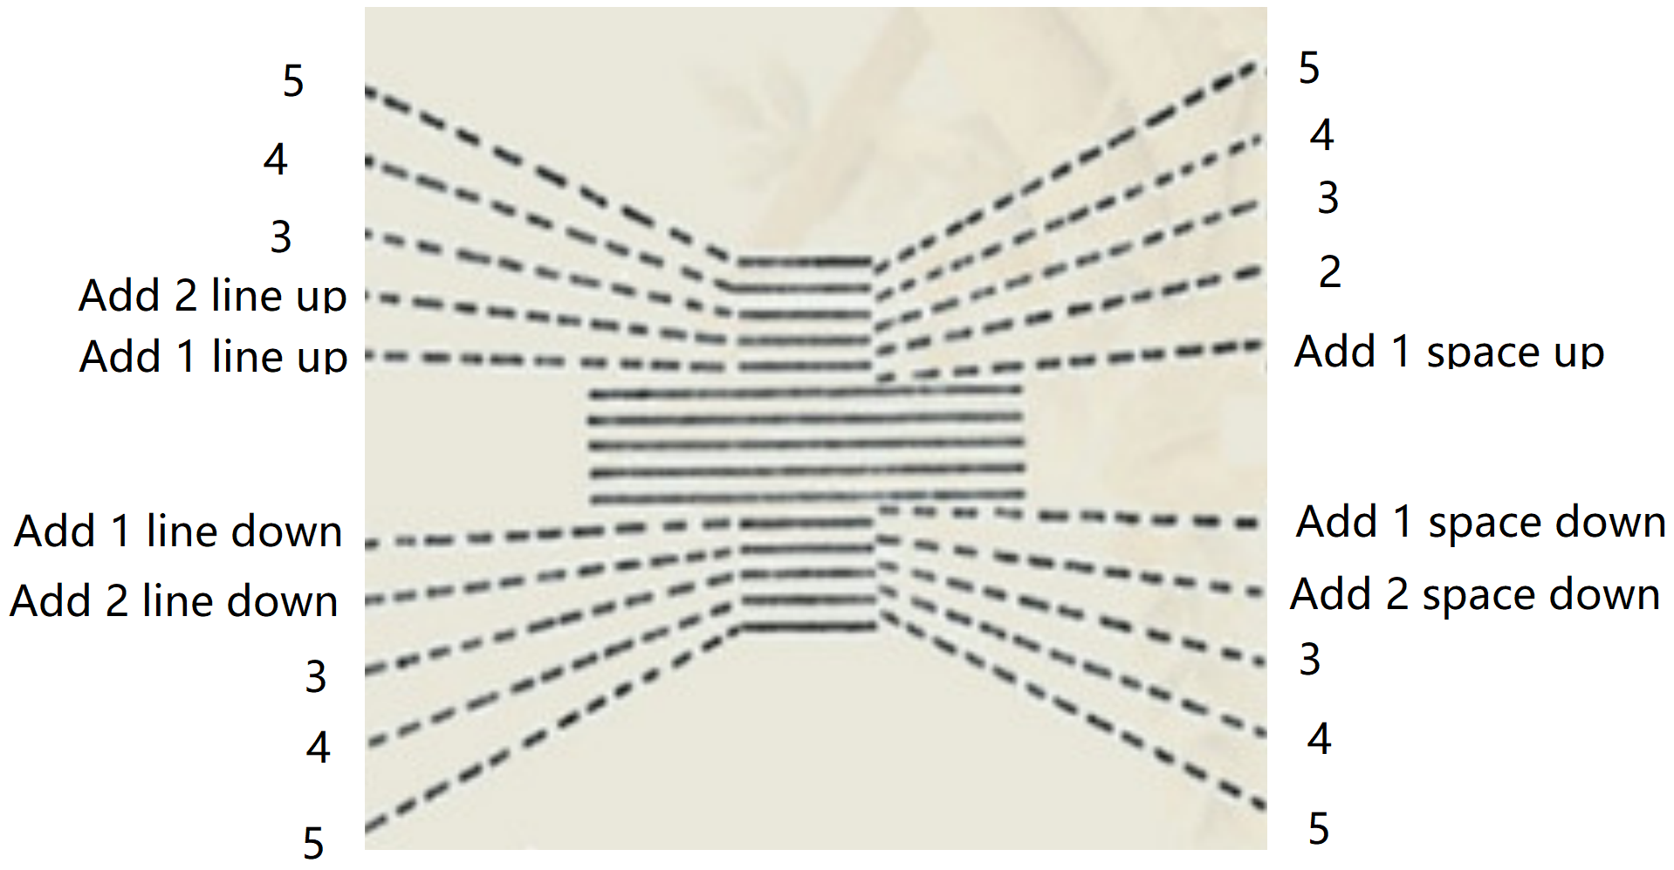

Figure 2

The calculation method of ledger line and extra space is: the upper ledger line and extra space are calculated from bottom to top, and the below ledger line and extra space are calculated from top to bottom.

After understanding the line and space of the staff, let’s understand the positions of tones.

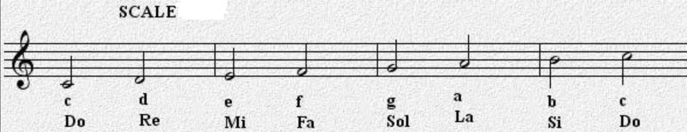

The main function of the scale chart is to see where the notes are on the staff.

You can see that the below ledger line 1 is “do”, that is, C, which can be used in upper and lower case, and we use upper case. The lower extra space 1 is “re”, that is, D. Line 1 is “mi”(E), space 1 is “fa”(F), line 2 is “so”(G), space 2 is “la”(A), line 3 is “si”(B), and space 3 is “do”(C) with a higher tone.

Now that we have learned to read the staff, let’s take a look at the staff of “Little star”.

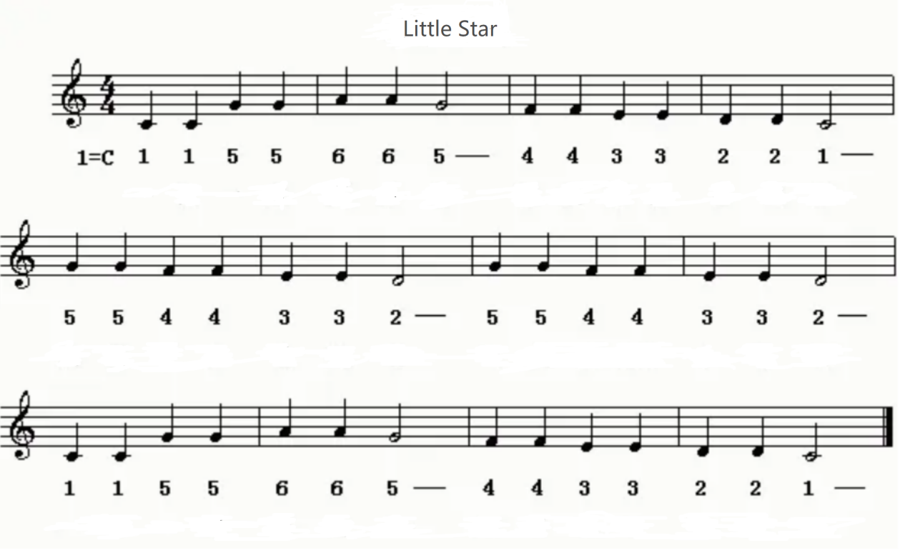

You can see that the score starts with 4 4, the quarter note is one beat, and each bar has four beats, 1=C, that is, C key.

The time of a bar is 1 second. A solid note is a quarter note, which is 1/4 beat, and the pause time is 1/4 second. A hollow note is a half note, which is 1/2 beat, and the pause time is 1/2 second.

According to the staff of “Little star”, let's write its corresponding notes first. Both upper and lower case are the same. We write uppercase characters, starting with the mediant C4.

Because most of them are 1/4 beats, the following ones with /2 are 1/2 beats, and the others are 1/4 beats.

C4、C4、G4、G4、A4、A4、G4/2、F4、F4、E4、E4、D4、D4、C4/2、

G4、G4、F4、F4、E4、E4、D4/2、G4、G4、F4、F4、E4、E4、D4/2、

C4、C4、G4、G4、A4、A4、G4/2、F4、F4、E4、E4、D4、D4、C4/2

Now we have written all the notes of “Little star”.

**（2）Example code**

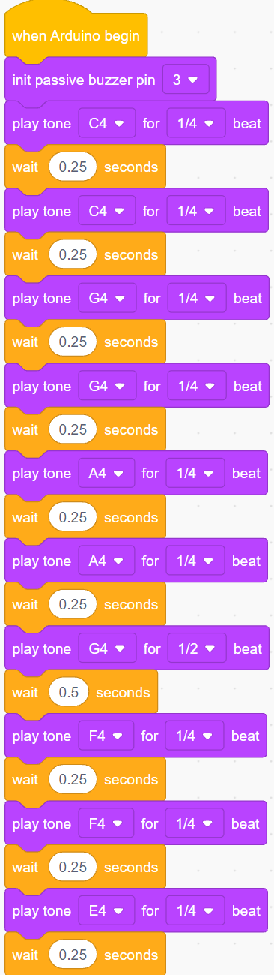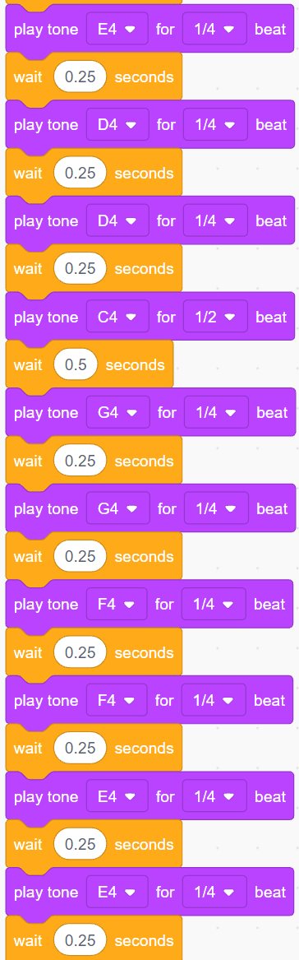

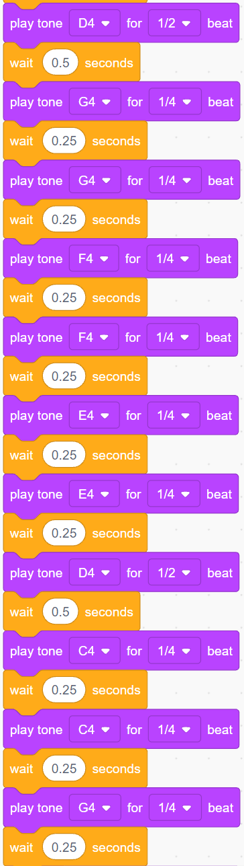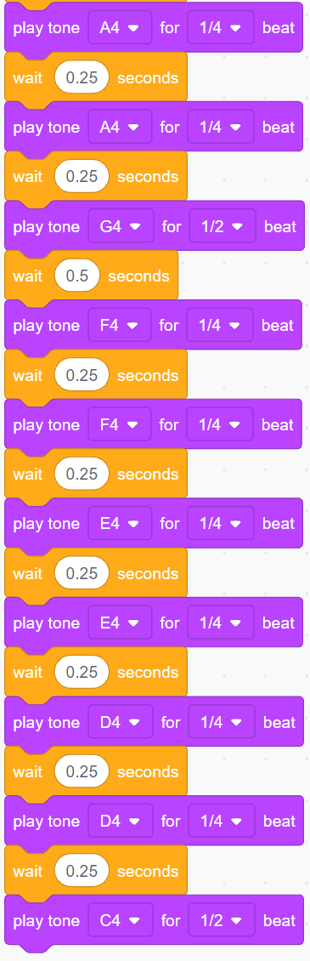

After writing the notes of the music score, the program is relatively simple, as long as the corresponding notes and pause time are written.

Upload the program to see if it is correct.

We also provided programs for several songs, including "Worms fly" and "Two tigers".